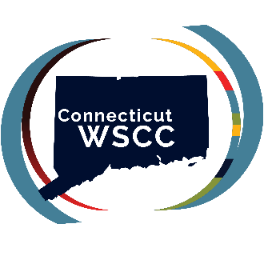
Introduction to the CT WSCC Partnership On-Demand Webinar Series Transcript

Welcome to the WSCC on-demand webinar series. There are 10 webinars in this series, each corresponding with one domain of the Whole School, Whole Community, Whole Child model. Each webinar will begin with an overview of the WSCC model and an introduction to our practice briefs, before a deep dive into the WSCC domain of focus.

This webinar will provide an introduction to the Connecticut WSCC Partnership. The CT WSCC Partnership is a joint collaboration between the University of Connecticut’s Collaboratory on School and Child Health and the Rudd Center for Food Policy and Health. Before we begin, we want to acknowledge our funding partners and share that the content of this webinar does not necessarily reflect the official views of the CDC or the Department of Health and Human Services.

In 2023, the CDC awarded 20 cooperative agreements to support states and tribal nations in their work to implement the WSCC model in schools. As you can see from the map, Connecticut is the only state in New England and one of only two (with Pennsylvania) in the entire Northeast/Mid-Atlantic region to receive this funding.

With this funding, the Connecticut WSCC Partnership was established. It’s a five-year collaboration between the UConn Collaboratory on School and Child Health and the UConn Rudd Center for Food Policy and Health. The goal of the project is to provide professional development and technical assistance to Connecticut schools to support their implementation of the WSCC model. Ultimately, this work seeks to improve the health and well-being of Connecticut's students.

Our team has been engaged in supporting implementation of the WSCC model for several years now. One tool that we had previously created was the WSCC practice briefs. These are concise, 3-4 page summaries of each of the 10 WSCC domains.

Each brief contains four sections: a description of the domain, a review as to how the domain is connected to student outcomes, a synthesis of evidence-informed practices in that domain, and additional resources to support learning and implementation.

We began the creation of these briefs back in 2017. At that time, we conducted a systematic review of the evidence supporting each of the WSCC domains. We specifically looked for evidence of associations with academic, social, emotional, behavioral, and physical health outcomes for students. We also gathered evidence-based practices that are used in each domain. We classified each of these practices as requiring a low, moderate, or high resource demand, assisting schools with choosing appropriate initiatives for their setting. In 2020-2021, we repeated our process to ensure that each brief contained the most up-to-date evidence and revised each practice brief accordingly. We continue to update the briefs to be sure they contain current findings and recommendations.

On the website, you’ll also find our suite of WSCC tools. In addition to the practice briefs, these include resources and tools to assess policies and practices and guide action planning for sustained change.

Our Suite of WSCC tools and additional resources can be found on our website at ctwscc.org.

Thank you for joining us! To view the webinars in our WSCC on-demand webinar series, please visit our website at ctwscc.org. If you have any questions about the Connecticut WSCC Partnership, please feel free to contact us at ctwscc@uconn.edu.

